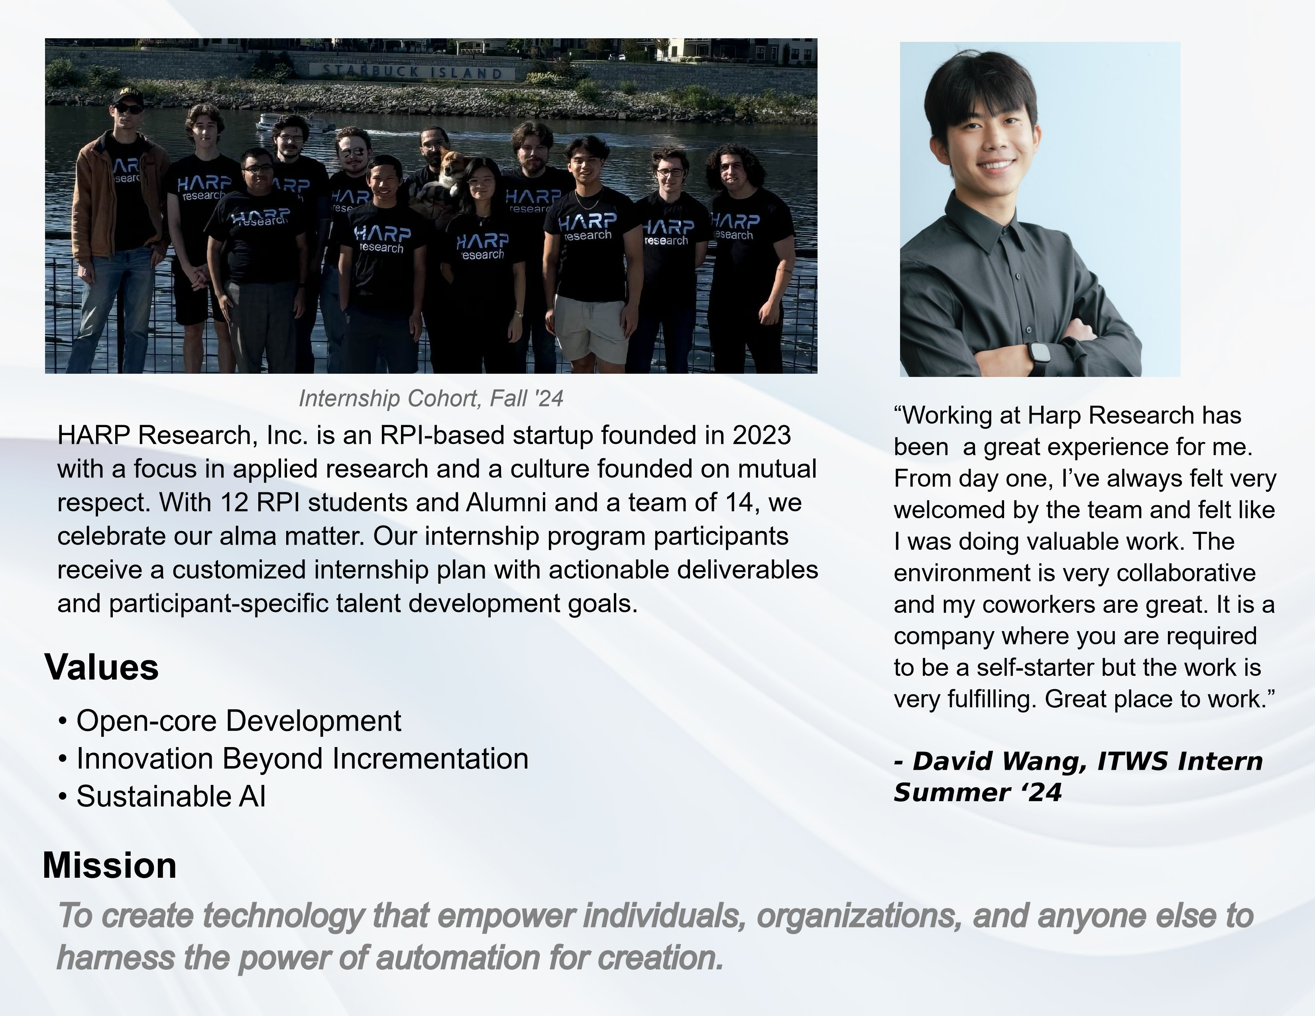



research

**Follow us on LinkedIn:**

https://www.linkedin.com/company/

harpresearch/

**Contact**

:

.

✉

talent@harpresearch.ai

☎

(802) 440-0618



https://www.harpresearch.ai

**Come visit us in-person:**

19

3rd St., Troy NY

12180

**Positions for Spring and**

**Summer '25:**

.



**Interest Form:**



• Applied Quantum Machine

Learning Internship

• Market Research and Strategy

Internship

• Applied Cognitive Linguistics

Internship

• Applied Mathematics Internship

• Hybrid ML Workflow Engineering

Internship